EX:03- Create a simple cloud software application for Property Buying &amp; Rental
process (In Chennai city) using any Cloud Service Provider to demonstrate SaaS.
Aim
To Create a simple cloud software application for Property Buying &amp; Rental process (In Chennai city) using any Cloud Service Provider to demonstrate SaaS.
Procedure
- Login to Zoho Creator – Use your account credentials to sign in and enter the Zoho Creator platform.
- Start Building an App – Click “Create Application” and decide whether to use a ready-made template or begin with a blank one.
- Create Forms & Modules – Design forms (like customer details, property/booking info) and add the required fields.
- Add Workflows & Rules – Set up automation, validations, and logic to manage user actions smoothly.
- Launch the App – Save your work and publish the app on Zoho’s cloud system.
- Enable SaaS Usage – Share the app’s URL so that users can access and use it online as a SaaS solution.
Output
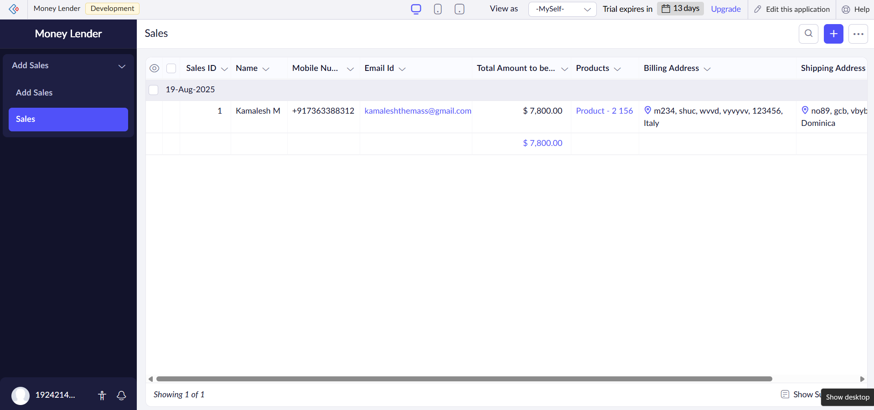
Result
Thus, a simple cloud software application for Property Buying &amp; Rental process (In Chennai city) using any Cloud Service Provider to demonstrate SaaS was successfully created.

